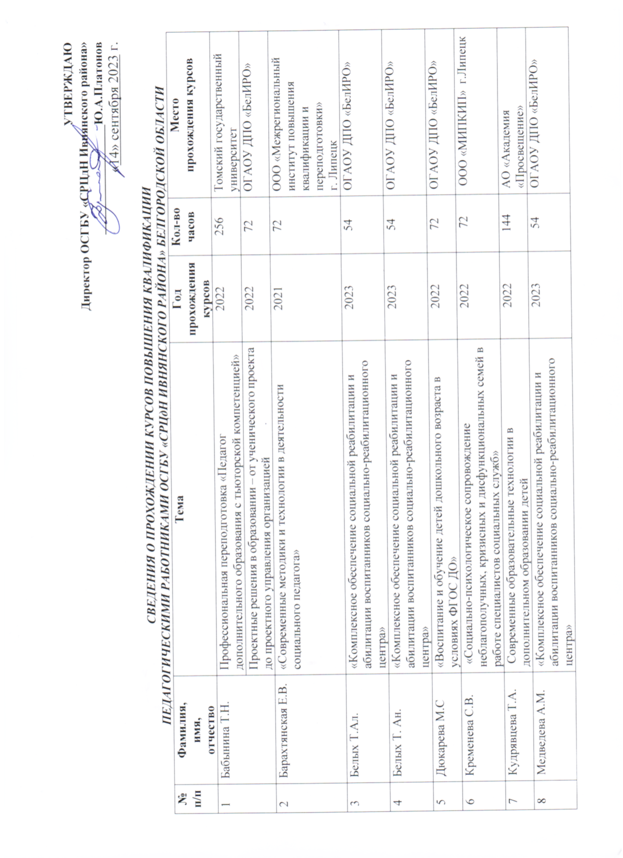

C:\Users\SRCdN-12\Pictures\2023-09-27_002.tif